**Instructions**

[*Screen 1*]

WELCOME!

Thank you for participating in our study. The session will proceed in several stages.

Stage 1: Cognitive Test

Stage 2: Categorization Test

Stage 3: Behavioral and Socio-Demographic Survey

Stage 4: Receive Payment

Press Enter to continue…

[*Screen 2-27*]

Cognitive Test

This task will proceed as follows:

You will be presented with 24 questions.

In each question, you will be asked to analyze a geometric pattern and identify the missing part to complete the series.

The stage takes approximately 15 minutes.

Press Enter to continue…

*Notes:* After this, they will be presented with an example followed by 24 problems.

First, consider the following example:

The objective is to identify the missing element that completes the pattern of shapes.

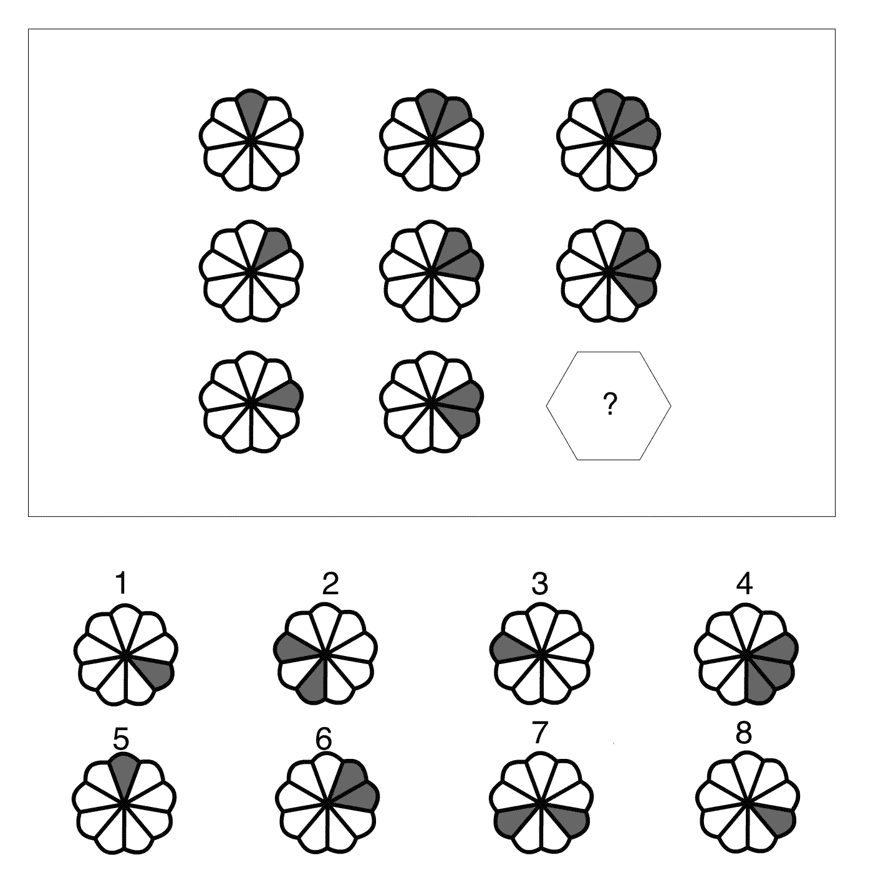

Here the fourth alternative (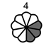 ) is the most appropriate match among the eight available options.

Question 1.

What is the missing element?

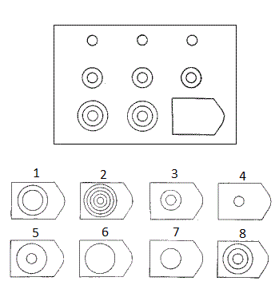

**Your answer**:

Question 2.

What is the missing element?

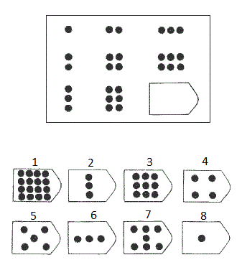

**Your answer**:

Question 3.

What is the missing element?

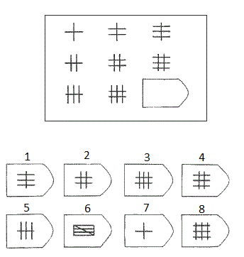

**Your answer**:

Question 4.

What is the missing element?

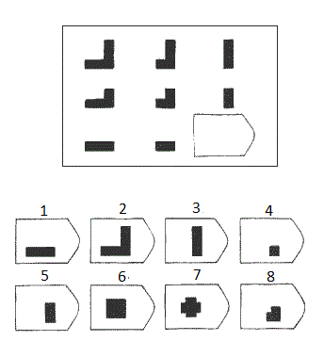

**Your answer**:

Question 5.

What is the missing element?

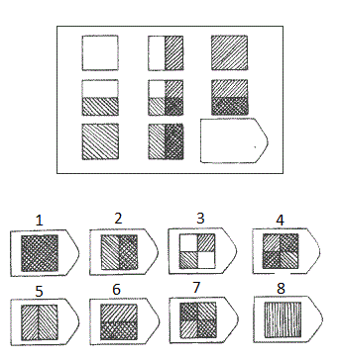

**Your answer**:

Question 6.

What is the missing element?

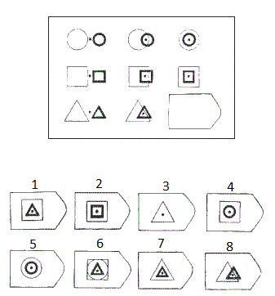

**Your answer**:

Question 7.

What is the missing element?

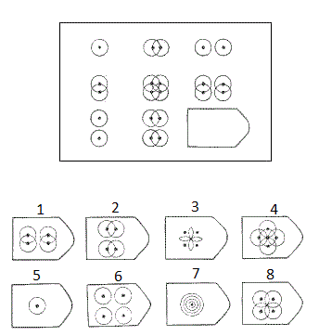

**Your answer**:

Question 8.

What is the missing element?

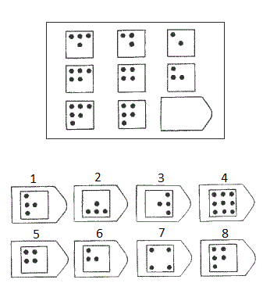

**Your answer**:

Question 9.

What is the missing element?

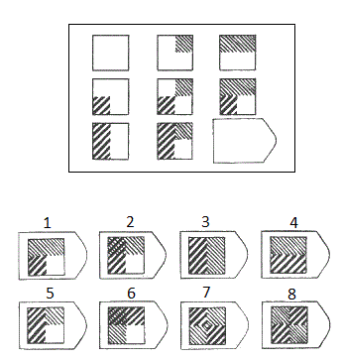

**Your answer**:

Question 10.

What is the missing element?

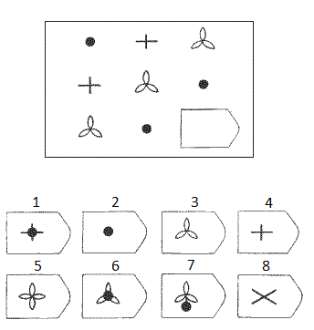

**Your answer**:

Question 11.

What is the missing element?

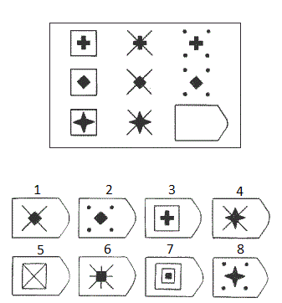

**Your answer**:

Question 12.

What is the missing element?

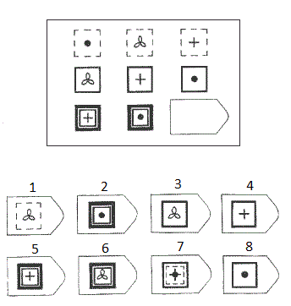

**Your answer**:

Question 13.

What is the missing element?

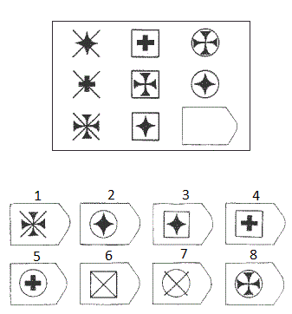

**Your answer**:

Question 14.

What is the missing element?

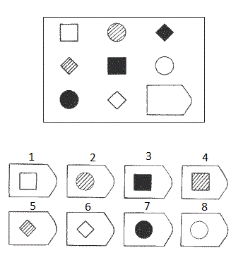

**Your answer**:

Question 15.

What is the missing element?

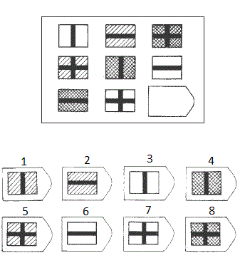

**Your answer**:

Question 16.

What is the missing element?

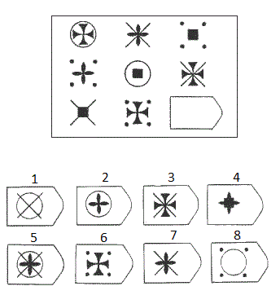

**Your answer**:

Question 17.

What is the missing element?

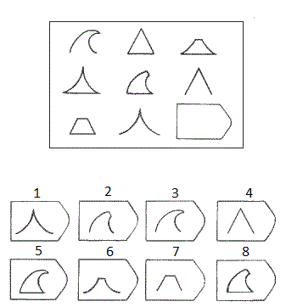

**Your answer**:

Question 18.

What is the missing element?

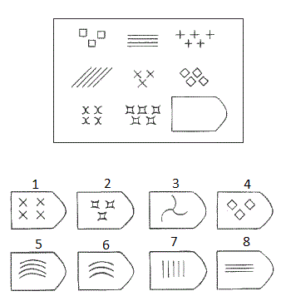

**Your answer**:

Question 19.

What is the missing element?

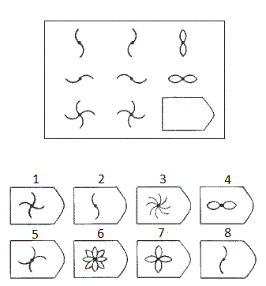

**Your answer**:

Question 20.

What is the missing element?

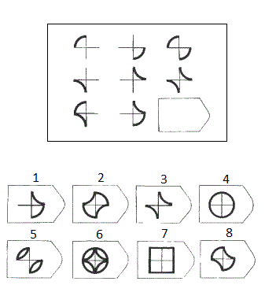

**Your answer**:

Question 21.

What is the missing element?

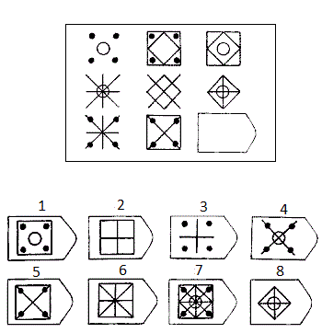

**Your answer**:

Question 22.

What is the missing element?

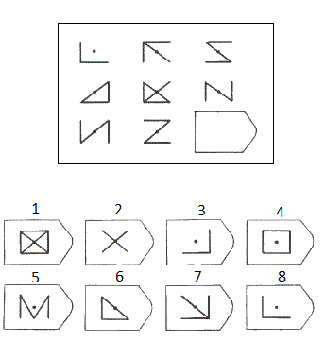

**Your answer**:

Question 23.

What is the missing element?

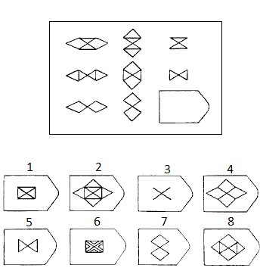

**Your answer**:

Question 24.

What is the missing element?

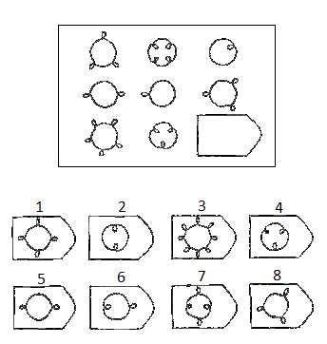

**Your answer**:

[*Screen 28*]

This concludes this stage of the experiment.

Now we will proceed to the Categorization Test.

Press Enter to continue…

[*Screen 29-49*]

Categorization Test

Place your left and right index fingers on the E and I keys. At the top of the screen are 2 categories. In the task, words and images appear in the middle of the screen.

When the word/image belongs to the category on the left, press the **E** key as fast as you can. When it belongs to the category on the right, press the **I** key as fast as you can. I you make an error, a red X will appear. Correct errors by hitting the other key.

Please try to go *as fast as you can* while making as few errors as possible.

When you are ready, please press the [Space] bar to begin.

*Notes:* Block 1 consists of 20 practice trials. Healthy food images will be assigned to left-key response while unhealthy food images will be assigned to right-key response.

[*Screen 50-78*]

Now, the categories have changed, but the rules remain the same.

Please try to go *as fast as you can* while making few errors as possible. Correct errors by hitting the other key.

When you are ready, please press the [Space] bar to begin.

*Notes:* Block 2 consists of 28 practice trials. Good taste/enjoyment words will be assigned to left-key response while bad taste/lack of enjoyment will be assigned to right-key response.

[*Screen 79-103*]

Now the four categories you saw separately will appear together. Remember, each word/image fits in only one of the four categories. The label/item colors may help you identify the appropriate category.

Use the **E** key for the two categories on the left and the **I** key for the two categories on the right. Again, try to go *as fast as you can* without making mistakes. Correct errors by hitting the other key. Practice this combination now.

When you are ready, please press the [Space] bar to begin.

*Notes:* Block 3 consists of 24 practice trials. Healthy food images + good taste/enjoyment words will be assigned to left-key response. Unhealthy food images + bad taste/lack of enjoyment will be assigned to right-key response.

[*Screen 104-152*]

Please continue the task as you were doing. Again, try to go *as fast as you can* without making mistakes. Correct errors by hitting the other key.

When you are ready, please press the [Space] bar to begin.

*Notes:* Block 4 consists of 48 critical test trials. Healthy food images + good taste/enjoyment words will be assigned to left-key response. Unhealthy food images + bad taste/lack of enjoyment will be assigned to right-key response.

[*Screen 153-193*]

Notice the categories form before have switched sides. Please practice this new configuration now. Remember to try to go *as fast as you can* while making few errors as possible. Correct errors by hitting the other key.

When you are ready, please press the [Space] bar to begin.

*Notes:* Block 5 consists of 40 practice trials. Unhealthy food images will be assigned to left-key response while healthy food images will be assigned to right-key response.

[*Screen 194-218*]

Notice the four categories have been combined again, but in a new configuration. Please practice this combination now, and remember to go *as fast as you can* while making few errors as possible. Correct errors by hitting the other key.

When you are ready, please press the [Space] bar to begin.

*Notes:* Block 6 consists of 24 practice trials. Unhealthy food images + good taste/enjoyment words will be assigned to left-key response. Healthy food images + bad taste/lack of enjoyment will be assigned to right-key response.

[*Screen 219-267*]

Please continue the task as you were just doing it, and remember to go *as fast as you can* while making as few mistakes as possible. Correct errors by hitting the other key.

When you are ready, please press the [Space] bar to begin.

*Notes:* Block 7 consists of 48 critical test trials. Unhealthy food images + good taste/enjoyment words will be assigned to left-key response. Healthy food images + bad taste/lack of enjoyment will be assigned to right-key response.

[*Screen 268*]

This concludes this stage of the experiment.

Now we will proceed to the Behavioral and Socio-Demographic survey.

Press Enter to continue…

[*Screen 269*]

Behavioral and Socio-Demographic Survey

Please answer the following survey questions.

1. **Please enter your ID number.**
2. **How often do you exercise? (Include only periods of exercise longer than 20 minutes).**
3. Never
4. Once a month
5. Once a week
6. 2-3 times per week
7. 4-6 times per week
8. Once a day
9. More than once a day
10. **Do you currently smoke cigarettes?**
11. **How many hours did you sleep last night?**
12. **How many days per week do you eat breakfast?**
13. 0 days
14. 1 day
15. 2 days
16. 3 days
17. 4 days
18. 5 days
19. 6 days
20. 7 days

[*Screen 270*]

1. **At what time did you consume your last meal today?**
2. **Rate on the scale from 1 to 9, how hungry were you feeling at the beginning of the session (1= Not at all; 9= Extremely hungry).**
3. **Rate on the scale from 1 to 5, how strongly do you agree with the following two statements (1= Strongly disagree; 5= Strongly agree)**
4. Things that are good for me rarely taste good
5. There is no way to make food healthier without sacrificing taste.

[*Screen 271*]

1. **Do you currently have a serious health issue?**
2. **Please indicate your age in years.**
3. **Please indicate your Major by Department.**
4. **Please indicate your current academic year.**
5. Freshman
6. Sophomore
7. Junior
8. Senior

[*Screen 272*]

1. **Please indicate your gender.**
2. Male
3. Female
4. **Please indicate your race.**
5. Asian/Pacific Islander
6. African American
7. Caucasian/White
8. Native America/Indigenous
9. Hispanic
10. Other (Please list below)
11. **Please indicate your household yearly income for 2017. (Include all forms of income, including salary, interest and dividend payments, tips, scholarship support, student loans, parental support, and allowance)**
12. Less than $30,000
13. $30,000 - $39,999
14. $40,000 - $49,999
15. $50,000 - $59,999
16. $60,000 - $69,999
17. $70,000 - $79,999
18. $80,000 - $89,999
19. $90,000 - $99,999
20. 100,000 - $149,999
21. $150,000 or more

[*Screen 273*]

This concludes today’s experiment!

You will now receive your payment.

Thank you very much for your participation.